Smart Bridge Data Science Internship

Project Report

Project Title:

**Power Consumption Analysis for House Holds Using IBM Watson Machine Learning**

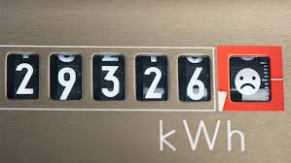

Team Members

Naman Arora

Dhruv Arora

Vishwakarma Manishkumar Durbhash

Asif Ali Sherani

Krishna Agarwal

**INDEX**

|  |  |  |
| --- | --- | --- |
| **S.no** | **Topic** | **Page no.** |
| 1 | **Introduction**   1. Overview 2. Purpose | 3 |
| 2 | **Literature Survey**   1. Existing Problem 2. Proposed Solution | 4 |
| 3 | **Theoretical Analysis**   1. Block Diagram 2. Software requirement | 5-6 |
| 4 | **Experimental Investigations** | 6-7 |
| 5 | **Flowchart** | 7 |
| 6 | **Screenshots** | 8-9 |
| 7 | **Result** | 9 |
| 8 | **Advantages and disadvantages** | 9-10 |
| 9 | **Applications** | 10 |
| 10 | **Conclusion** | 10 |
| 11 | **Bibliography** | 10 |
| 12 | **Appendix**   1. Source Code 2. UI output screenshot | 11-13 |

**INTRODUCTION**

**OVERVIEW:**

India is the world's third largest producer and third largest consumer of electricity. The national electric grid in India has an installed capacity of 383.37 GW as of 31 May 2021.

During the fiscal year (FY) 2019-20, the gross electricity generated by utilities in India was 1,383.5 TWh and the total electricity generation (utilities and non-utilities) in the country was 1,598 TWh. The gross electricity consumption in FY2019 was 1,208 kWh per capita.

Electricity consumption in Indian homes has tripled since 2000. The percentage of households with access to electricity has increased from 55% in 2001 to more than 80% in 2017. In 2014, an electrified Indian household consumed about 90 units (kWh) of electricity per month on an average; enough to run four tube-lights, four ceiling fans, a television, a small refrigerator, and small kitchen appliances with typical usage hours and efficiency levels in India.

To achieve reduction in electricity consumption, it is vital to have current information about household electricity use. This Guided Project mainly focuses on applying a machine-learning algorithm to calculate the power consumed by all appliances. This will help you track the power consumed on regular intervals for all kinds of appliances which use heavy loads such as Air Conditioners, Oven or a washing machine etc.

**PURPOSE:**

Today, Electricity has become an essential part of our lives. We cannot think of our lives without it. Today, there are more air conditioners, heaters etc. in the houses of India than before but the average annual site energy use per home has declined as today’s electronic equipments are more efficient in terms of energy consumption.

**LITERATURE SURVEY**

**EXISTING PROBLEM:**

Due to development in technology and usage of more and more smart electricity meters, there is a large amount of data present today about the electricity usage.

This data represents a multivariate time series of power-related variables, that in turn could be used to model and even forecast future electricity consumption.

In this project, we will be using the dataset with different time series and has the total energy consumption and will be forecasting the energy consumption for the future by analyzing the given dataset.

**PROPOSED SOLUTION**

* The household power consumption dataset that describes electricity usage for a single house over four years.
* How to explore and understand the dataset using a suite of line plots for the series data and histogram for the data distributions.
* How to use the new understanding of the problem to consider different framings of the prediction problem, ways the data may be prepared, and modeling methods that may be used.

**THEORETICAL ANALYSIS**

**BLOCK DIAGRAM**

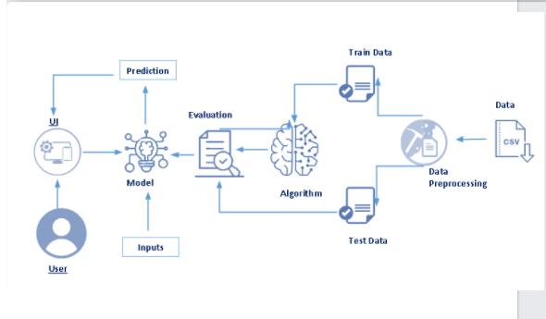

**SOFTWARE REQUIREMENT**

* **NumPy** - is a library for the Python programming language, adding support for large, multi-dimensional arrays and matrices, along with a large collection of high-level mathematical functions to operate on these arrays.
* **Pandas** - software library written for the Python programming language for data manipulation and analysis. In particular, it offers data structures and operations for manipulating numerical tables and time series.
* **Matplotlib** - Matplotlib is a plotting library for the Python programming language and its numerical mathematics extension NumPy.
* **Seaborn** - Seaborn is a data visualization library built on top of matplotlib and closely integrated with pandas data structures in Python.
* HTML page “index.html” for our home page and print out the final predictions made, is stored in the templates folder.
* Let us build app.py flask file which is a web framework written in python for server-side scripting. Let’s see step by step procedure for building the backend application Import required libraries.

**EXPERIMENTAL INVESTIGATION**

The household power consumption dataset is a multivariate time series dataset that describes the electricity consumption for a single household over four years. The data was collected for power consumption of the household for every minute.

There are 8 different variables present in the dataset. They are:

* **DateTime**: The date and time for each and every record in the dataset.
* **Global_Active_Power**: The total active power consumed by the household in kilowatts.
* **Gloval_Reactive_Power**: The total reactive power consumed by the household in kilowatts.
* **Voltage**: Average voltage in volts
* **Global_Intensity**: Average current intensity in amperes.
* **Sub_metering_1**: Active energy for kitchen in watt-hours
* **Sub_metering_2**: Active energy for laundry in watt-hours.
* **Sub_metering_3**: Active energy for climate control systems in watt-hours.

Active and reactive energy refer to the technical details of alternative current.

In general terms, the active energy is the real power consumed by the household, whereas the reactive energy is the unused power in the lines.

As we can see from the dataset, the sum of Sub_metering_1, Sub_metering_2 and Sub_metering_3 is not equal to the Global_Active_Power as it is assumed that there are circuits in the house other that kitchen, laundry and climate control. The remaining watt-hours can be calculating by converting Global_Active_Power into watt-hours and subtracting the sub metered active energy in watt-hours from it

**FLOW CHART**



**SNAPSHOTS**

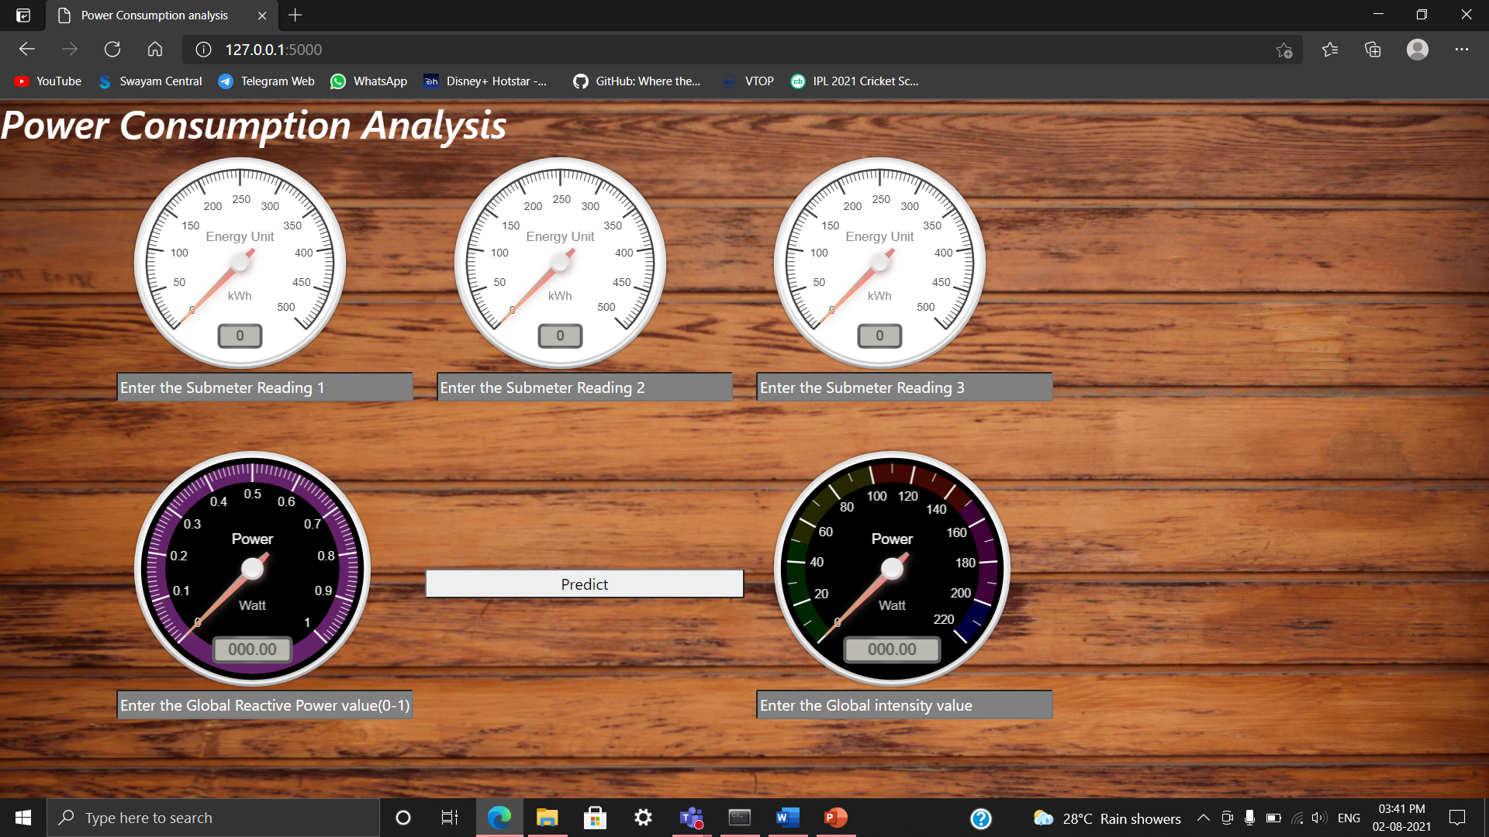

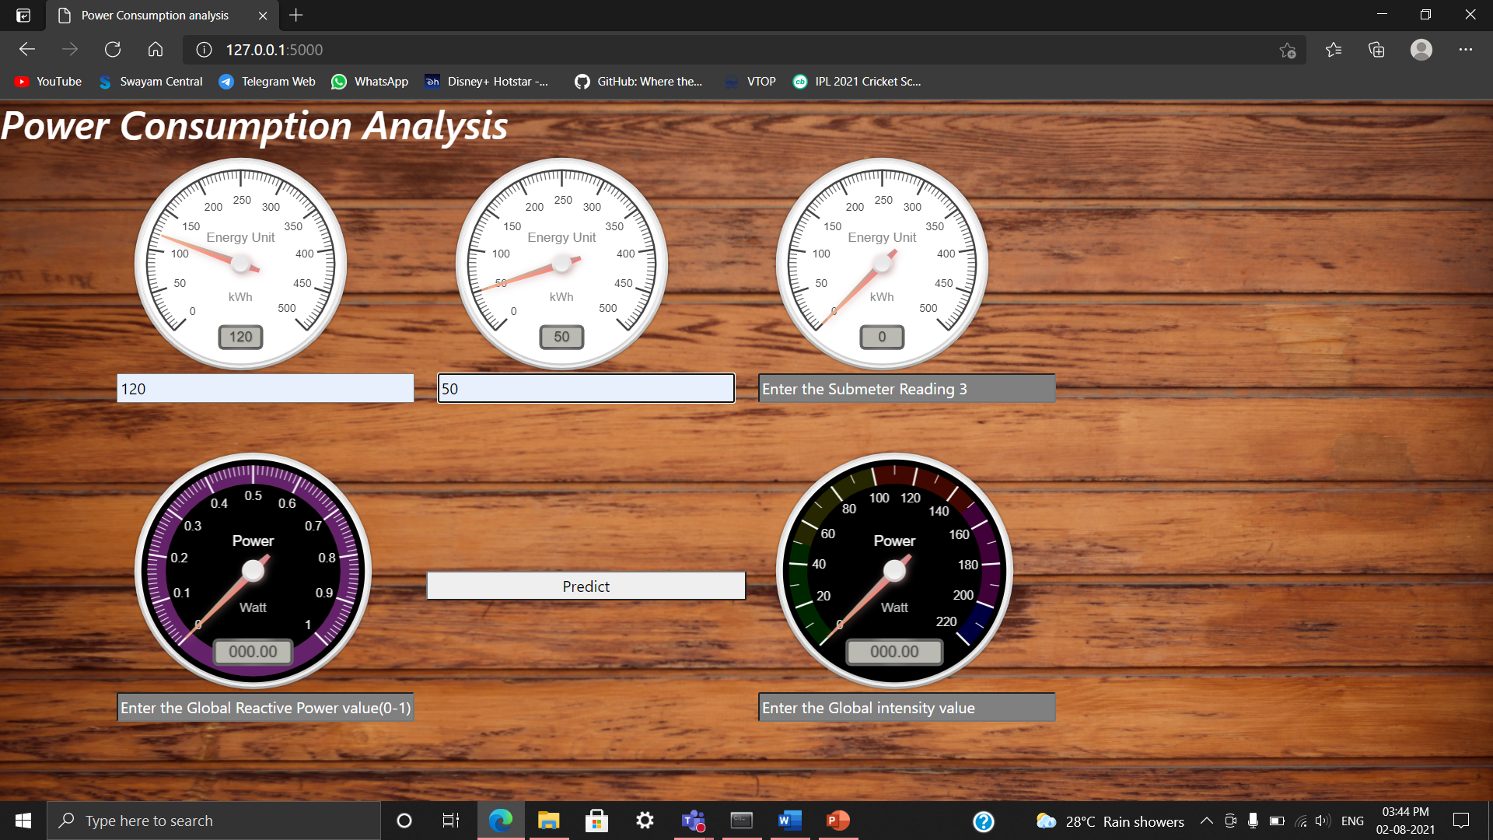

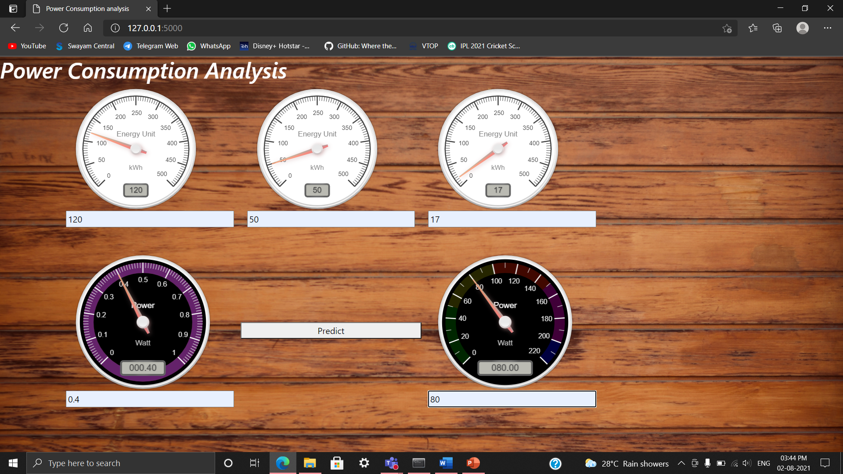

**RESULT**

* Open the anaconda prompt from the start menu.
* Navigate to the folder where your app.py resides.
* Now type “python app.py” command.
* It will show the local host where your app is running on http://127.0.0.1.5000/
* Copy that local host URL and open that URL in the browser. It does navigate me to where you can view your web page.
* Enter the values, click on the predict button and see the http://127.0.0.1.5000/predict on the web page.

**ADVANTAGES AND DISADVANTAGES**

**ADVANTAGES:**

* Perhaps the most obvious benefit of an energy consumption analysis lies in its potential to protect your bottom line. By analyzing a building’s energy from the inside out, using the machine learning model, a comprehensive energy analysis can significantly reduce utility bills.
* In addition to reducing energy expenses and protecting against rising energy costs, an energy consumption analysis can also result in operational benefits.

**DISADVANTAGES:**

The main disadvantage of electricity consumption prediction is that this is just a prediction and no one could be 100% certain. If we prepare for the future in order to fulfil the electricity needs as predicted, it could result in the loss of wealth for the government.

**APPLICATIONS**

1.To assess the energy efficiency and energy usage of their homes.

2. To use the new understanding of the problem to consider different framings of the prediction problem, ways the data may be prepared, and modeling methods that may be used.

3.The household power consumption dataset is a multivariate time series dataset that describes the electricity consumption for a single household over four years.

**CONCLUSION**

Finally, total power consumption by all the appliances is calculated and displayed.

**BIBLIOGRAPHY**

* <https://www.kmbdg.com/news/energy-consumption-analysis/>
* <https://seaborn.pydata.org/>
* [The Python Standard Library — Python 3.9.6 documentation](https://docs.python.org/3/library/)

**APPENDIX**

**SOURCE CODE**

import requests

from flask import Flask,request,render_template

import numpy as np

import pickle

import json

app = Flask(__name__)

# NOTE: you must manually set API_KEY below using information retrieved from your IBM Cloud account.

API_KEY = "iYiNfOynXMl7i1cZx-myCNOiksgysPq9EFE9cEKWw0jD"

token_response = requests.post('https://iam.cloud.ibm.com/identity/token', data={"apikey": API_KEY, "grant_type": 'urn:ibm:params:oauth:grant-type:apikey'})

mltoken = token_response.json()["access_token"]

header = {'Content-Type': 'application/json', 'Authorization': 'Bearer ' + mltoken}

@app.route('/')

def home():

return render_template("index.html")

@app.route('/predict',methods=["POST"])

def predict():

input_features = [float(x) for x in request.form.values()]

input = [input_features[3],input_features[4],input_features[0],input_features[1],input_features[2]]

print(input_features)

features_value = [np.array(input)]

features_name = ['Global_reactive_power', 'Global_intensity', 'Sub_metering_1',

'Sub_metering_2', 'Sub_metering_3']

payload_scoring = {"input_data": [{"field": [['Global_reactive_power','Global_intensity','Sub_metering_1','Sub_metering_2','Sub_metering_3']], "values": [input]}]}

response_scoring = requests.post('https://us-south.ml.cloud.ibm.com/ml/v4/deployments/a4517dcd-1391-437b-a5c5-831dc5ee2d28/predictions?version=2021-08-01', json=payload_scoring, headers={'Authorization': 'Bearer ' + mltoken})

print("Scoring response")

predictions=response_scoring.json()

pred=predictions['predictions'][0]['values'][0][0]

print(pred)

return render_template('index.html', prediction_text='Global Active Power: {}'.format(pred))

if __name__=="__main__":

#port = int(os.getenv('PORT', 8080))

#app.run(host='0.0.0.0', port=port, debug=False)

app.run(debug=False)

**OUTPUT UI SCREENSHOT**

